WEEK1-1
ROLL NO:241801277
Name: Subha Sri.S
Q1) This is a simple challenge to help you practice printing to stdout.We 're starting out by printing the most famous computing phrase of all time ! In the editor below,use either printf or cout to print the string Hello,World! to stdout.
Input Format
you need to read any input in this challenge.
Output Format
Print Hello World!
sample Output 1
Hello, World!
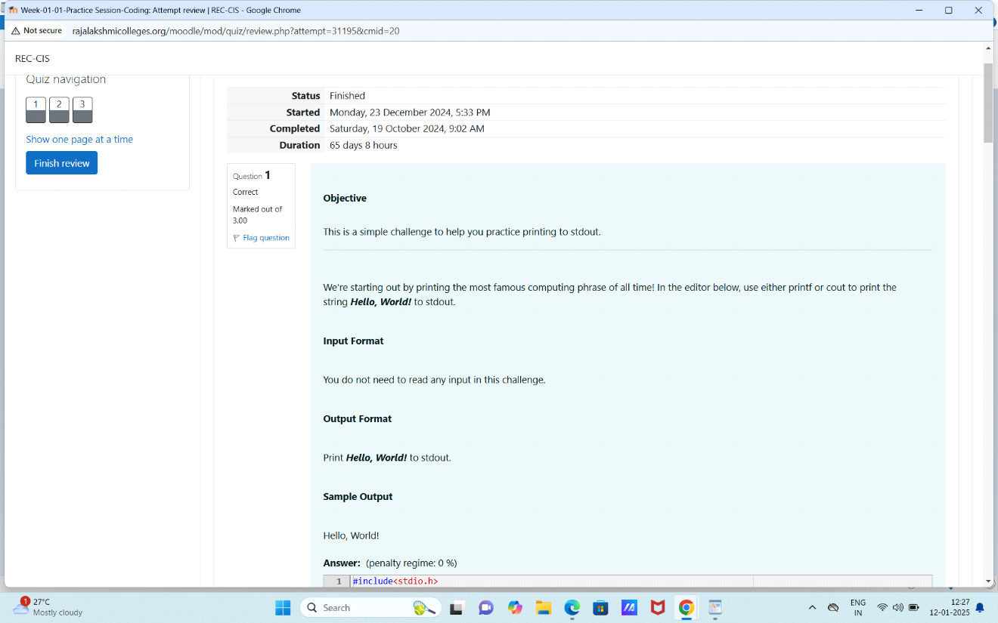
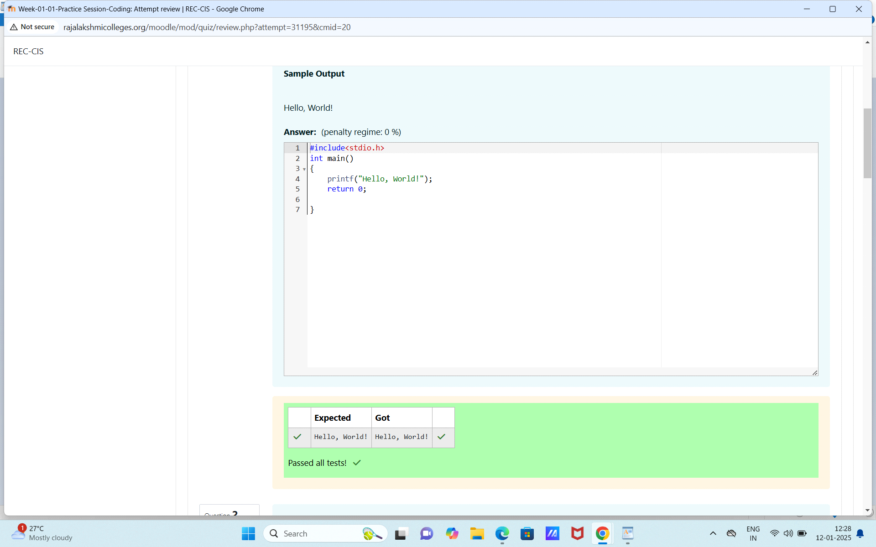

Q2) This challenge will help you to learn how to take a character, a string and a sentence as input in C. Totake a single character specified by the argument char to student.
char c;
scanf("%c",&ch)
printf("%c",ch);
Input format
First take a character, ch as input. Then takes the string,s as input.Lastely,take the sentence sen as input.
Output format
Print three lines of output. The first line prints the character,ch. The second line prints the string,s. The third line prints the sentence,sen.
Sample input 1
C
Program
programming using C
Sample output 1
C
Program
Programming using C
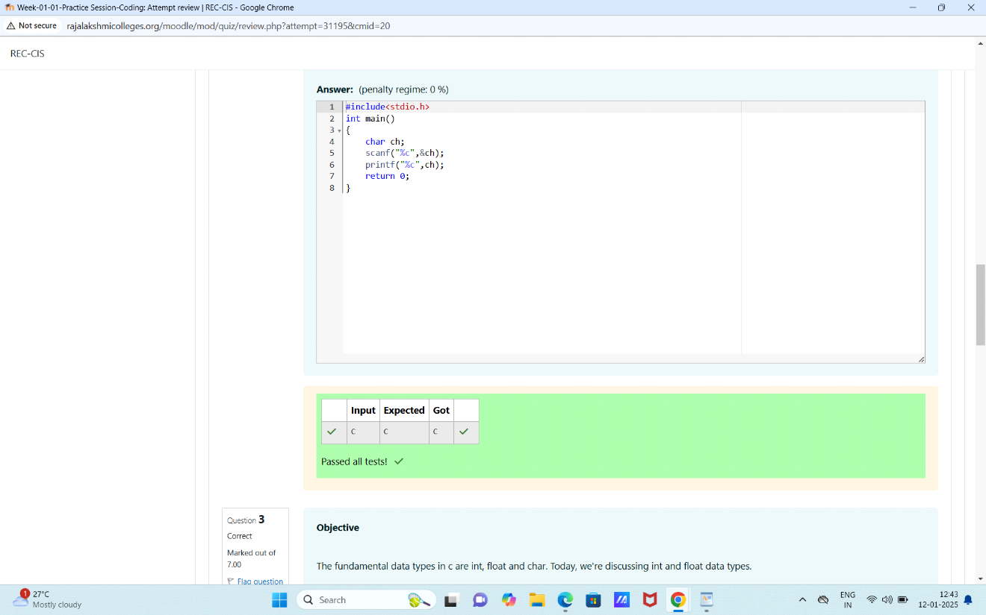

Q3) The fundamental data types in c are int,float and char.Today,we'are discusing int and float data types.
The printf() function prints the given statement to the console. The syntax is printf("format string",argument_list);.In the function,if we are using an integer, cahracter,string or float as argument, then in the format string we have to write %d (integer),%c (character),%s (string),%f (float)respectively.
The scanf() function reads the input data from the console.The syntax is ("format string",argument_list);. For example: The scanf("%d",&number) statement reads intger number from the console and stores the given value in variable number.
To
input two integers seperated by a space on a single line, the command is scanf("%d%d",&n,&m),where n and m are the two integers.
Input Format
The first line contains two integer.The second line conyainstwo floating point numbers.
Constraints:
1<=integer variable<=10^4,1<=float variables<=10^4
Output Format:
Print the sum and difference of both integers seperated bya space on the first line,and the sum and differences of both float(scaled to1 decimal places) seperated by a space on the second line.
Sample Input
10 4
4.0 2.0
Sample Output
14 6
6.0 2.0
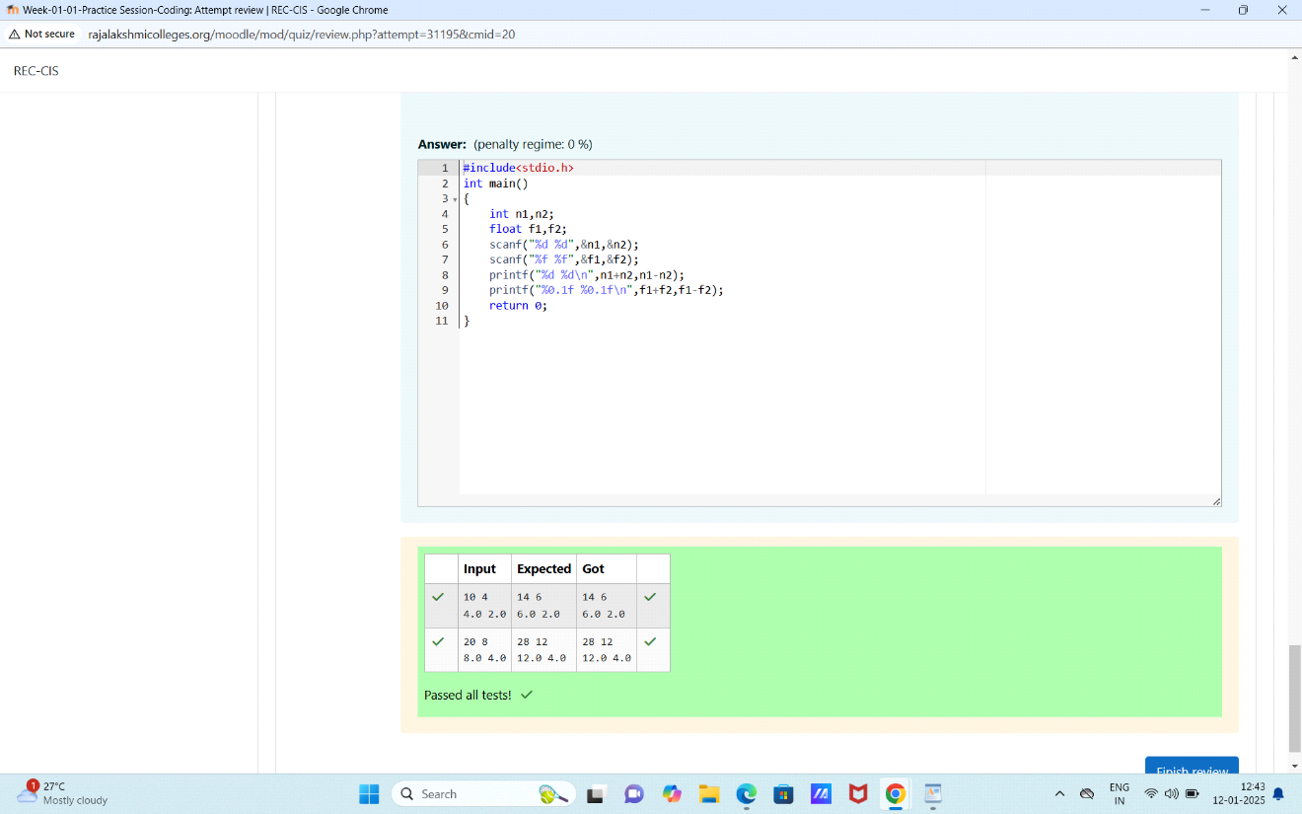
Week 1-1:
ROLL NO: 241801277
NAME: Subha Sri.S
Q1) Write a program as input a name(as a single character) and marks of three test as m1,m2and m3 of a studen considering all the three marks have been given in integer format.Now, you need to calculate the average of the given marks and print it along with the name as mentioned in the output format section.as the test marks are in integes and hence calculate the ab=veragein integer as well.That is,you need to print the integer part of the average only and neglect the decimal part.
Input Format
Line1: Name(Single character)
Line2: Marks scored in the 3 test seperated by single space.
Output Format:
First line of output prints the name of the student. Second line of the output prints the average mark.
Constraints
Marks for each student lie in the range 0 to 100(both includive)
Sample Input 1:
A
3 4 6
sample Output:
A
4
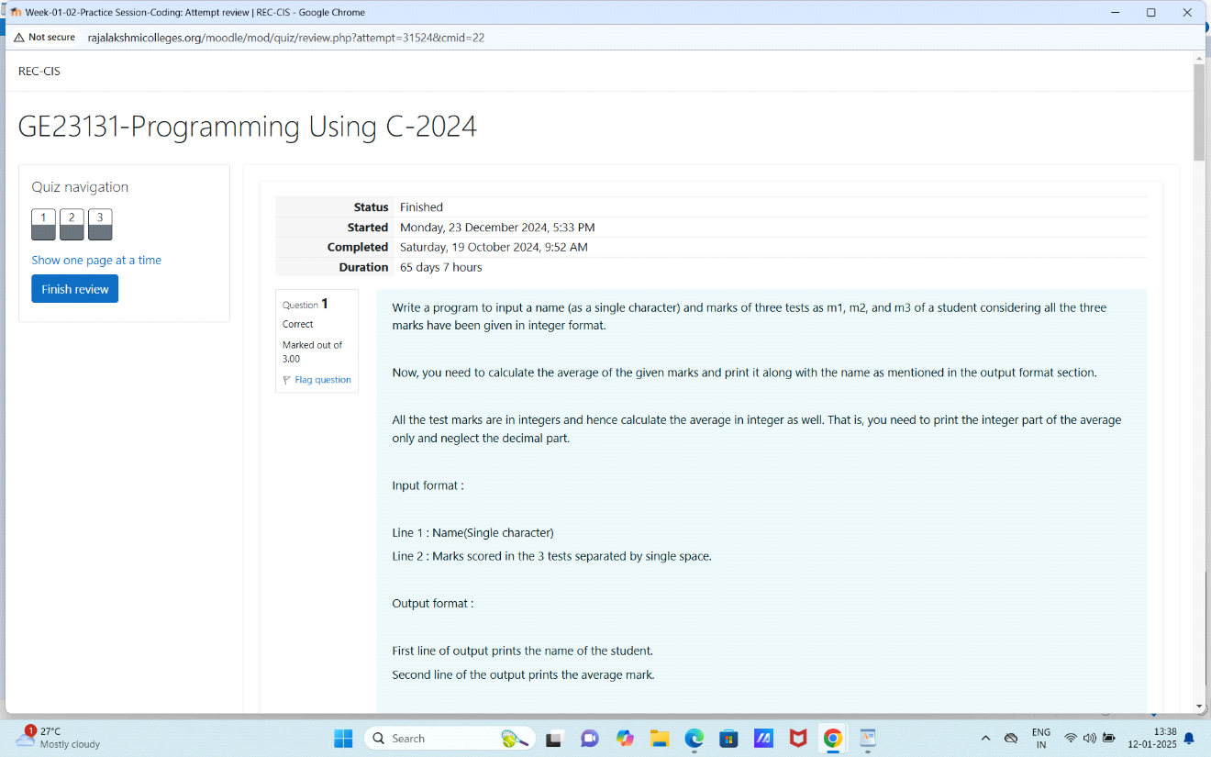
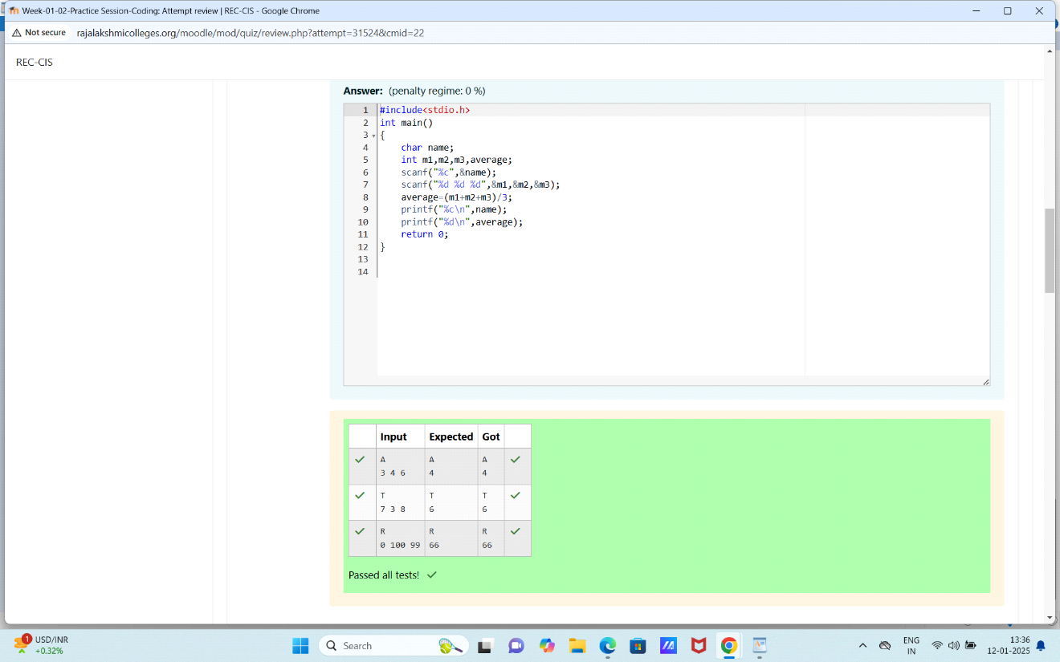
Q2)Some C data types, their specifiers and their most comon bit widths are as follows:
* Int ('%d"): 32 Bit integer
* Long ("%lf"): 64 bit integer
* Char("%c"): Character type
* Float("%f"): 32 bit real value
* Double("%lf"): 64 bit real value
Input format
Input consists of the follwing space-seperated values: int,long,char,float,and double respectively.
Output format
print the each element on a new line in the same order it was received as input.Note that the floating-point value should be correct upto three decimal places and the double to 9 decimal places.
Sample Input
3
12345678912345
a
334.230
14049.30493
Sample Output
3
12345678912345
a
334.230
14049.304930000
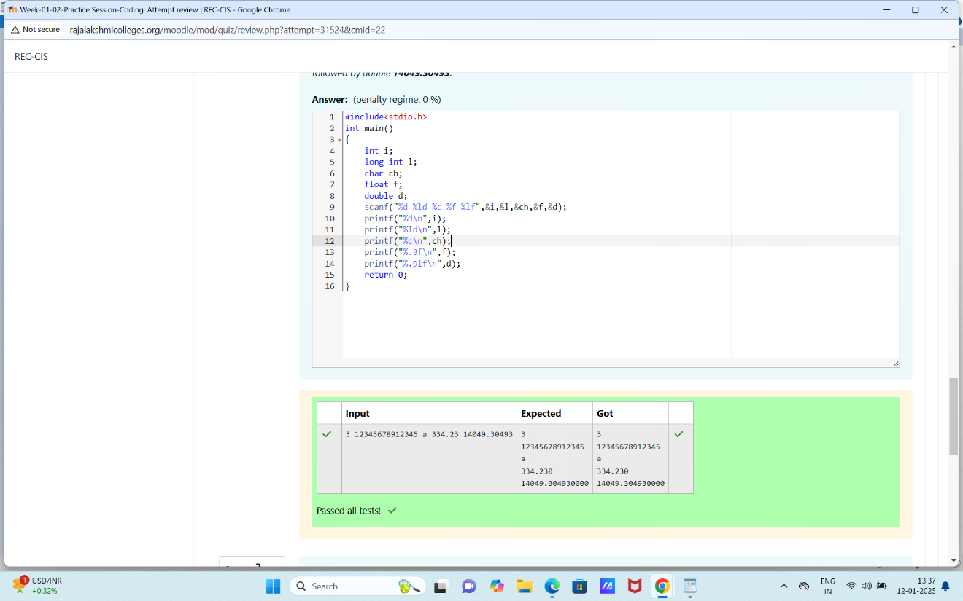
Q3) Write a program to print the ASCII value and the adjacent characters of the given character.
Input format
Reads the character
Output format
First line prints the ASCII value,second line prints the previous character and next character of the input character of the input character.
Sample Input
E
Sample output
69
D F
